Year 10

Chemistry

Research Assignment

Name: _______________

Class: _______

Due date: _________

**Marking Key**

|  |  |
| --- | --- |
| **Breakdown** |  |
| Questions 1 - 8 | /38 Marks |
| Reference List | /5 Marks |
| Draft Submission | /5 Marks |
| **Total** | **/48 Marks** |

**Assignment Instructions:**

**Students must complete this assessment individually**

You **must** hand in three things:

1. Completed Draft copy (research etc./completed workbook)
2. One final good copy of questions answered.
3. Reference list correctly formatted.

**Question 1: Gold**

Explain why the following properties lustre, malleability and ductility are suitable for gold jewellery making.

(3 marks)

|  |
| --- |
|  |
|  |
|  |
|  |
|  |
|  |

**Question 2: Calcium**

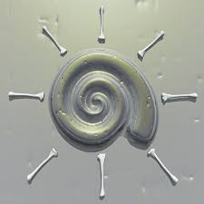

1. Research the properties of the element calcium. (2 marks)

|  |
| --- |
|  |
|  |
|  |
|  |
|  |

1. Explain why calcium metal is never found as a native element. (2 marks)

|  |
| --- |
|  |
|  |
|  |
|  |
|  |

1. Detail the process used to extract calcium metal. (2 marks)

|  |
| --- |
|  |
|  |
|  |
|  |
|  |

**Question 3: Rust Prevention**

1. List some common metals used as a coating to prevent rust.

(3 marks)

|  |
| --- |
|  |
|  |

1. Which is the most effective metal for coating and why? (2 marks)

|  |
| --- |
|  |
|  |
|  |
|  |
|  |

1. Explain why iron is prone to rust. (2 marks)

|  |
| --- |
|  |
|  |
|  |
|  |
|  |

**Question 4: Galvanisation**

a) Define the term galvanised (concerning metals). (1 mark)

|  |
| --- |
|  |
|  |

b) What is the advantage of galvanising a metal? (2 marks)

|  |
| --- |
|  |
|  |
|  |
|  |

1. Why will tin-coated cans rust when scratched but galvanised iron will not? (1 marks)

|  |
| --- |
|  |
|  |
|  |
|  |
|  |
|  |

**Question 5: Sodium**

1. Research the properties of the element Sodium. (2 marks)

|  |
| --- |
|  |
|  |
|  |
|  |
|  |

1. Research paraffin wax/oil and explain why it needs to be used to store sodium safely. (2 marks)

|  |
| --- |
|  |
|  |
|  |
|  |
|  |

1. What happens to sodium when it is exposed to air? Why does this occur? (2 marks)

|  |
| --- |
|  |
|  |
|  |
|  |
|  |

**Question 6: Copper**

1. What colour is copper when its unexposed to air? (1 marks)

|  |
| --- |
|  |
|  |

1. What colour does copper turn when it is exposed to air? (1 marks)

|  |
| --- |
|  |
|  |

1. Considering the answers to a) and b) why might you use a protective coating of lacquer on copper? (2 marks)

|  |
| --- |
|  |
|  |
|  |
|  |

**Question 7: Anodes** 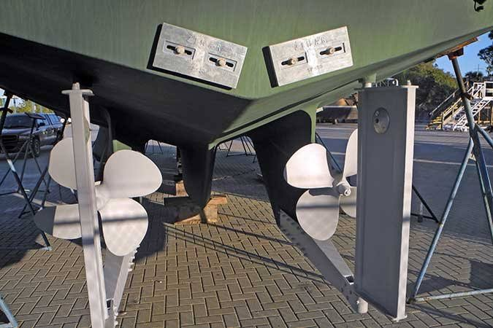

1. What is a sacrificial anode? (1 marks)

|  |
| --- |
|  |
|  |
|  |
|  |
|  |

1. What purpose do they serve on aluminium boats? (1 marks)

|  |
| --- |
|  |
|  |
|  |

1. Describe how a sacrificial anode works. (2 marks)

|  |
| --- |
|  |
|  |
|  |
|  |
|  |

1. Why can’t an anode be used in the air? (1 marks)

|  |
| --- |
|  |
|  |
|  |
|  |
|  |

**Question 8: Cumulative Poisoning**

Some metals such as lead and mercury are known as cumulative poisons. Research what this means, the symptoms of cumulative poisoning and how you might come into contact with these metals.

(3 marks)

|  |
| --- |
|  |
|  |
|  |
|  |
|  |
|  |
|  |
|  |
|  |
|  |
|  |
|  |
|  |
|  |
|  |

Reference Sheet – Internet



|  |  |  |  |  |  |  |
| --- | --- | --- | --- | --- | --- | --- |
| **Surname** | **Initial** | **Title of page** | **Full title of website** | **Date Written** | **Internet Address** | **Date of visit** |
| Brown | J. | ‘*Things in Space’* | Astronomy Facts | 1998 | <http://www.astronomyfacts.com> | 31 July 2019 |
|  |  |  |  |  |  |  |
|  |  |  |  |  |  |  |
|  |  |  |  |  |  |  |
|  |  |  |  |  |  |  |
|  |  |  |  |  |  |  |
|  |  |  |  |  |  |  |
|  |  |  |  |  |  |  |